MINUTES OF THE MEETING OF THE

LOUISIANA STATE MUSEUM
BOARD OF DIRECTORS

Monday, May 13, 2013
12:30 pm – The Old U.S. Mint
New Orleans, Louisiana

The meeting of the Board of Directors of the Louisiana State Museum was called to order by Chairman Michael M. Davis at 12:30 p.m. at The Old U.S. Mint in New Orleans. A quorum was present.

Members Present: Jerry F. Adams, Madlyn B. Bagneris, Robert A. Barnett, Myrna B. Bergeron, William Curl, Michael M. Davis, Charles R. Davis, Rosemary Upshaw Ewing, Allen J. “AJ” Gibbs, Jeffrey Pipes Guice, Janet V. Haedicke, Ph.D., Aleta Leckelt, E. Ralph Lupin, M.D., H. Wayne McCullen, William J. Perret, M.D., Lawrence N. Powell, Ph.D., Anne F. Redd, and Diane K. Zink

Members Absent: Donna Winters and Philip Woollam

Also Present: Robert J. Cangelosi, Jr., President, Friends of the Cabildo
Dana Hansel, President, Louisiana Museum Foundation
Susan H. Maclay, Executive Director, Louisiana Museum Foundation
Mark A. Tullos, Jr., Director, Louisiana State Museum
Robert E. Wheat, Deputy Director, Louisiana State Museum

The minutes from the April 8, 2013 meeting were reviewed in advance. Mr. Guice MOVED, seconded by Ms. Ewing, to approve the April 8, 2013 LSM board minutes. Unanimously approved.

Chairman’s report
Chairman Davis said the Lt. Governor has appointed a new board member, Thomas Frère Kramer, M.D. He replaces Susan Brunner. He could not attend this board meeting because of a previously planned commitment, but will attend the June 10th meeting. He is a retired medical doctor. Dr. Perret knows him from medical school.

Mr. M. Davis introduced Jennae Biddiscombe, the new director of the Louisiana Sports Hall of Fame and Northwest Regional History museum. She is the former Registrar for LSM. Ms. Biddiscombe said she is very excited about her new position and is moving up to Natchitoches this week.

Mr. M. Davis recognized Greg Lambousy, who just returned from a trip to Paris, sponsored by the French Consul. The purpose was to meet with universities and museums in Paris regarding potential loans for the museum and further develop our relationship with the intern system we have there. Mr. Lambousy also visited the music museum there for our upcoming music exhibit.

Mr. M. Davis distributed a summary of the SHOF/Regional History museum opening events. He spoke with Lisa Babin, who is head of the SHOF Foundation about the details and hopes that board members can attend some, or all, of these events, listed below:

Thursday, June 27th
- 3-8pm press conference and reception at The Landing (SHOFF event)
- 8pm – Museum open to new inductees and families (SHOFF event)

Friday, June 28th
- 9am – Golf tournament in Alexandria (SHOFF event)
- 5:30pm – Media tour at Museum (SHOFF event)
- 6:30pm - Ribbon cutting at Museum (LSM event)
- 6:45pm - Interview session with Shaquille O’Neal and Chanda Rubin. Will take place next door to Museum (SHOFF event)
- 7:30pm – Grand Opening reception at Museum (SHOFF event)

Saturday, June 29th
- 8:30am – Members Only Breakfast at NSU (SHOFF event)
- 10-12 – Brunch for History partners at Museum (LSM event)
- 10-11am – Autographs at Prather Coliseum (SHOFF event)
- 1-5 pm – Museum open for SHOFF VIPs. List provided by SHOFF.
- 5pm – Reception and Silent Auction at Events Center (SHOFF event)
- 6pm - Induction ceremony at Events Center (SHOFF event)

Sunday, June 30th
- Museum open from 10-5 with free advanced timed tickets

Mr. M. Davis reminded the board to turn in their financial disclosure forms which are due by May 15, 2013.

The next LSM board meeting will be Monday, June 10th and the Irby/Finance Committee meeting will be on that same day at 10am.

The next Accessions Committee meeting will be July 10th.

Director's report
Mr. Tullos went through his report, which is below.

Museum Director
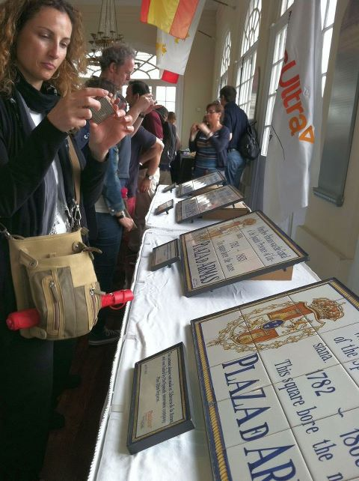
Mark Tullos
At a ceremony on Thursday, April 11, 2013, LSM and City officials hosted a business delegation from the city of Talavera de la Reina in Spain, and they presented four decorative street name ceramic tile plates to replace four time-worn ceramic tiles in Jackson Square. Chairman Davis and I addressed the group on behalf of the Louisiana State Museum.

I had an opportunity to visit with the State Librarian, Rebecca Hamilton regarding future partnerships and programming statewide. Other meeting included:
- Stephen Swain – Archbishop NOLA regarding partnerships and neighborhood concerns.
- French Chamber of Commerce
- FOC Board Meeting
- Legislative Hearing for CRT budget
  - NEH grant planning meeting
  - Meetings with the Natchitoches Friends regarding the Museum Store and the Opening Festivities
  - Louisiana Spirits Distillery regarding interpretive exhibition advice in the new tourism exhibit opening this summer
  - Attended a board meeting of the Vieux Carre Commission at the invitation of Susan Maclay
  - Spoke to the Exxon/Mobile Retired Employee group in Baton Rouge

Shooting from a helicopter for French Quarter Fest, photographer Zack Smith caught this amazing view of our "front yard" yesterday. Big friendly crowds, fabulous food, nonstop music, sunny skies and cool temperatures made this the best Fest yet.
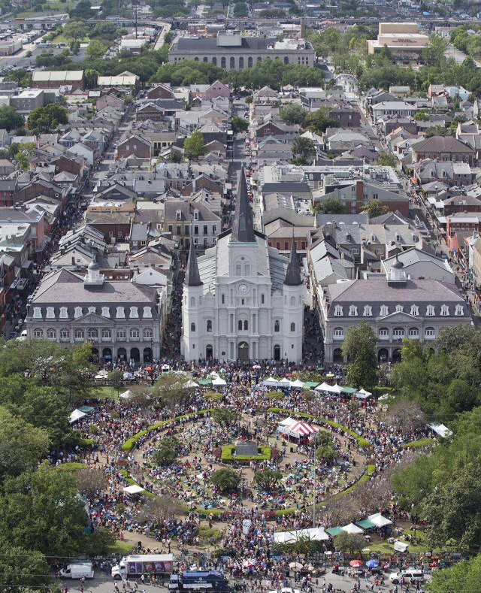
This week we hosted a for LSM staff and our staff partners from the Foundation and FOC. It was a beautiful day and I want to thank Wade Levy for his culinary talents preparing great Jambalaya lunch on the grounds of the Mint. Our Baton Rouge, Thibodaux, Patterson and Natchitoches Friends, were invited but as unable to attend. Bill Stark invited those LSM staff members to events in BR or will recognize their valuable contribution in a special way.
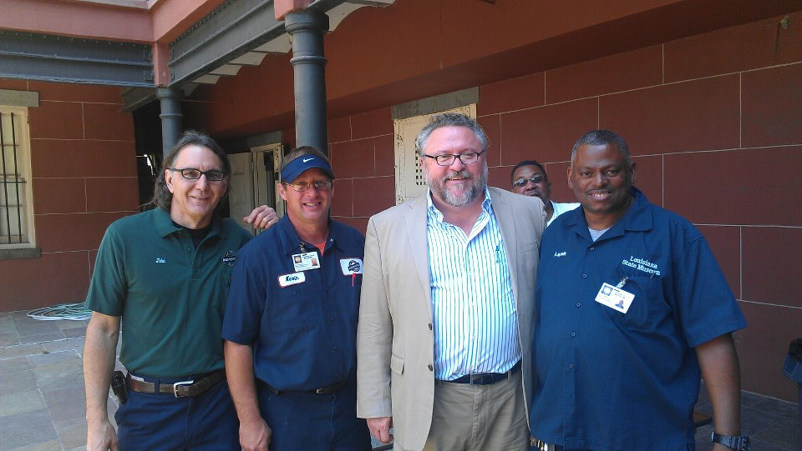
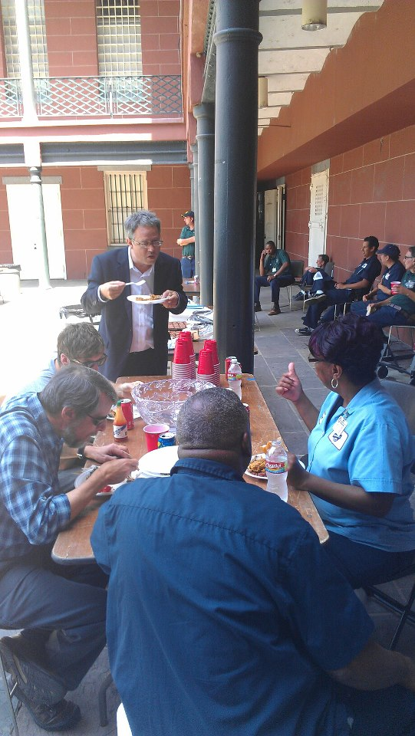
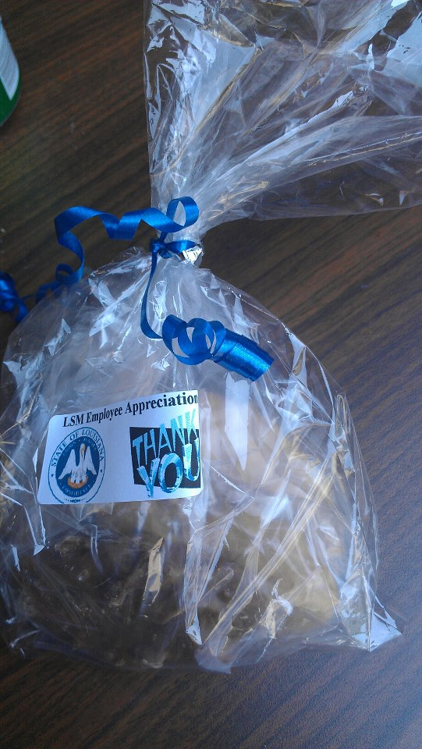
Officer Bailey made praline gifts

The following individuals joined LSM staff since January 1.
- Graham Cooper - Tourism Information Counselor
- Jennifer Long - Tourism Information Counselor
- Dayton House - Police Officer
- Quinton Askew – Police Officer
- Darnerio Rodgers – Police Officer (Sports Hall of Fame Museum)
- Jane Bailey – Police Officer
- Jesus Ramirez – Custodian
- Julius Sidney – Laborer
Last month I requested a pause in the scheduling of events at the Mint and other NOLA properties. I wanted to investigate how events are scheduled, the limitations on human resources and how to better manage everyone's time. The break also provided time to recruit, train and hire our two new Police Officers. Also, Robert Wheat was notified last week that funding was allocated for electrical upgrades at the Mint Museum. This will have a major impact on events next spring at the Mint. We now have a grasp on where we are headed and how we can better provide programs and services through LSM properties.
Administration
Robert Wheat
The museum was successful in obtaining approximately $500,000 in major repair funds from Facility Planning for the following projects:
- Upgrade of the complete electrical system, which will significantly enhance the electrical circuitry that will facilitate the installation of the future music exhibit at the Mint and bring the building up to current electrical code.
- Funding for the upgrade of the elevator controls to make them in compliance with current codes.
- To install a new HVAC system in the 1850 House, which will make that space much easier to manage as the new system will be individual systems for each floor, as opposed to a chill water system for the entire space.

Sports Hall of Fame
The Sports Hall of Fame now has an operational communication system, to include telephones and internet service. Facility Planning is currently in the process of purchasing all new furniture that will complement the building as opposed to having to use the old furniture from the Old Courthouse building. This includes all new furniture for the multi-purpose/education rooms, including tables and chairs. Also included are new appliances for the catering kitchen, which was not originally in the project, an ice-maker, stainless steel preparation table, convection oven and microwave.

Two Capital Outlay programs have received Priority 2 status for the upcoming budget year for the Cabildo and the Presbytere exterior renovation.

Marketing Communications Report
Arthur Smith
- The unveiling of Fats Domino’s restored Steinway grand piano at the Old U. S. Mint on May 2 attracted wide media coverage. In addition to front-page stories in The Advocate and The Times-Picayune (see attached), an Associated Press feature on the event was carried by more than 12,000 news organizations across the world – print, broadcast, and online.

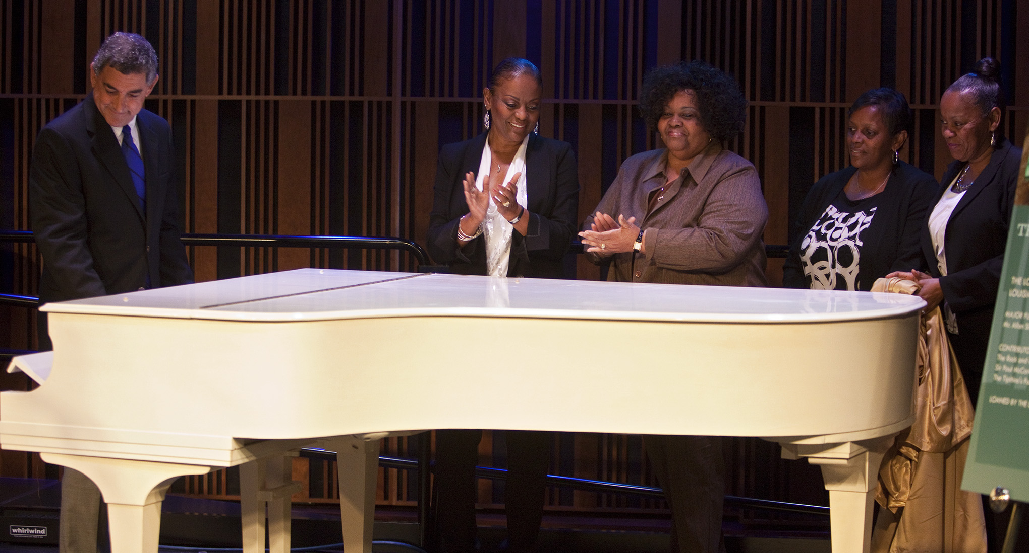
Dardenne with Domino's Daughters

- Supported by a $50,000 grant from the Louisiana Office of Tourism, the Museum is preparing to launch a statewide advertising campaign to promote the opening of the Louisiana Sports Hall of Fame and museum in Natchitoches. The campaign relies on a mix of sports and general interest media – including print, outdoor, radio and television – and carries the theme: “The House That Legends Built.” (See attached media plan and print ad for the summer issue of LSU’s alumni magazine).

Departmental Report
Capitol Park, E.D. White, Natchitoches & Patterson
Bill Stark, Museum Division Director
Capitol Park Museum
Curator Susan Moreau continued the Museum’s Walking Tours offered each spring and fall. On April 4 the theme was The History of Capitol Park. Guests learned about the historic sites located in the Capitol Park area. Such as, Zachary Taylor’s home site, Fort San Carlos, the Pentagon Barracks, and Louisiana State University’s 1st Baton Rouge campus among other interesting facts.

On Thursday April 11 the Capitol Park Museum hosted the Atchafalaya National Heritage Area’s Civil War Sesquicentennial Commemoration Speaker Series. Lt. Governor Jay Dardenne introduced speaker Thomas Gilmore, Director of Civil War Trust and his talk Civil War Battlefield Preservation.

A jazz concert featuring students from four of the East Baton Rouge Parish School System Gifted and Talented Music Programs was held on April 27. This free concert was enjoyed by more than 160 people on the Museum’s plaza.

The spring is always the busiest time for event rentals at the Capitol Park Museum. In addition to the many spring weddings, the museum has hosted the Legislative Black Caucus Prayer Breakfast on the first day of session; the Office of Cultural Development’s Cultural Connection event; and the Student of the Year Awards.

The Louisiana State Museum Friends are holding their annual gala fundraiser on June 8. “A Night at the Louisiana State Museum: Year of Louisiana Music” will feature Grammy award winning artist Chubby Carrier. The LSM Board will be receiving invitations.

E.D. White Historic Site
The site improvement project has been completed and includes improved drainage, additional exterior lighting and a new sign.

The Barataria-Terrebonne National Estuary Program (BTNEP) Paddle Bayou Lafourche event took place April 4-7. The E.D. White site is one of the shore stops along the way, allowing paddlers the opportunity rest and visit the historic site. This annual participation is one of the ways EDW is able to connect the history of the White family and their home to the natural resources that surround the old plantation.
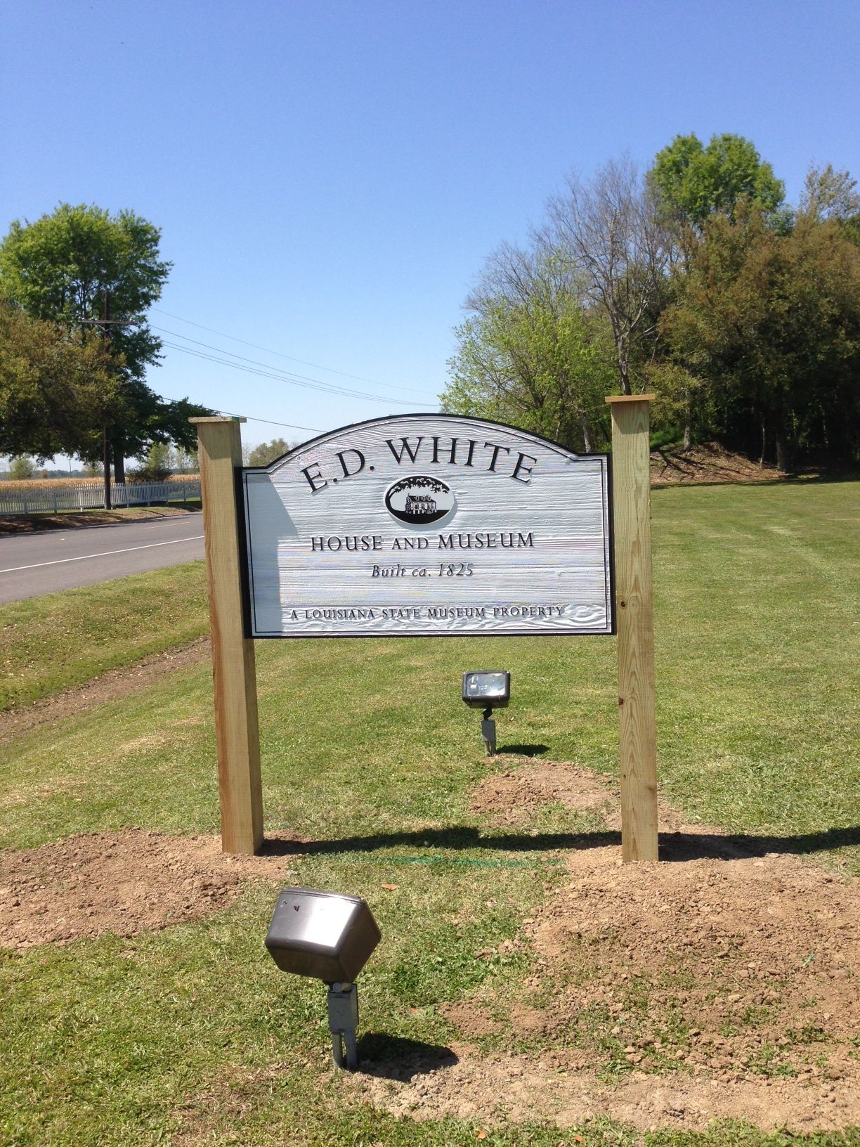

Louisiana State Museum – Patterson
The 23rd annual Cypress Sawmill Festival drew record crowds on April 5th – 7th. The 33,598 visitors to the three-day festival were able to enjoy a variety of entertainment, eat lots of food and got a close look at some of the artifacts featured at the Louisiana State Museum. The festival began in 1990 as a fundraiser to build a new museum in Patterson and has grown exponentially.

Featured entertainment included live bands and lumberjack shows throughout the weekend. Other events and activities included a softball tournament, bass tournament, golf tournament, fun walk, street fair, arts and crafts booths, antique car show, old engine display, and fireworks show honoring past and present law enforcement, firefighters, paramedics, emergency personnel, and armed forces.

A number of recent acquisitions by the Wedell Williams Aviation and Cypress Sawmill Foundation were added to the aviation gallery.

The exhibit Tarzan: Lord of the Louisiana Jungle closed in April. The changing exhibit gallery will house several of the Louisiana State Museum’s travelling panel exhibits throughout the summer before the installation in the fall. This change will allow for a new cycle of fall exhibit openings that will spread the museum’s public offerings throughout the year and provide a continuous exhibit throughout the spring school tour season.

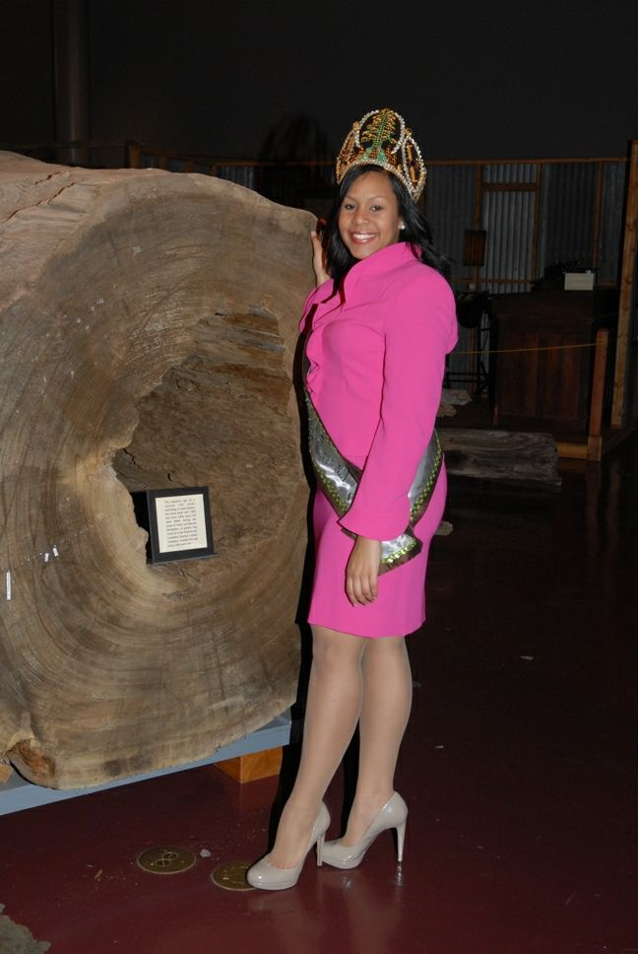

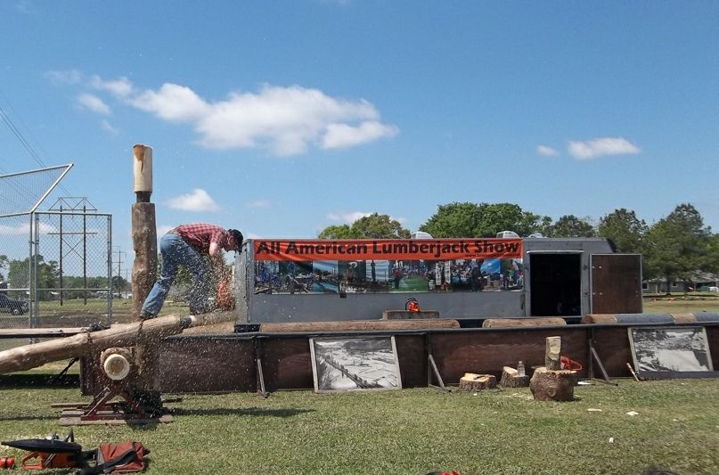

Louisiana State Museum – Natchitoches
The Louisiana Sports Hall of Fame and Regional History Museum continues to add staff with Officer Darnerio Rogers and Curator Shawn Ryder and most recently, Branch Director Jennae Biddiscombe. Jennae was promoted from the Museum’s Registrar position and has already been working to fill out the remainder of the staff and organize museum operations.

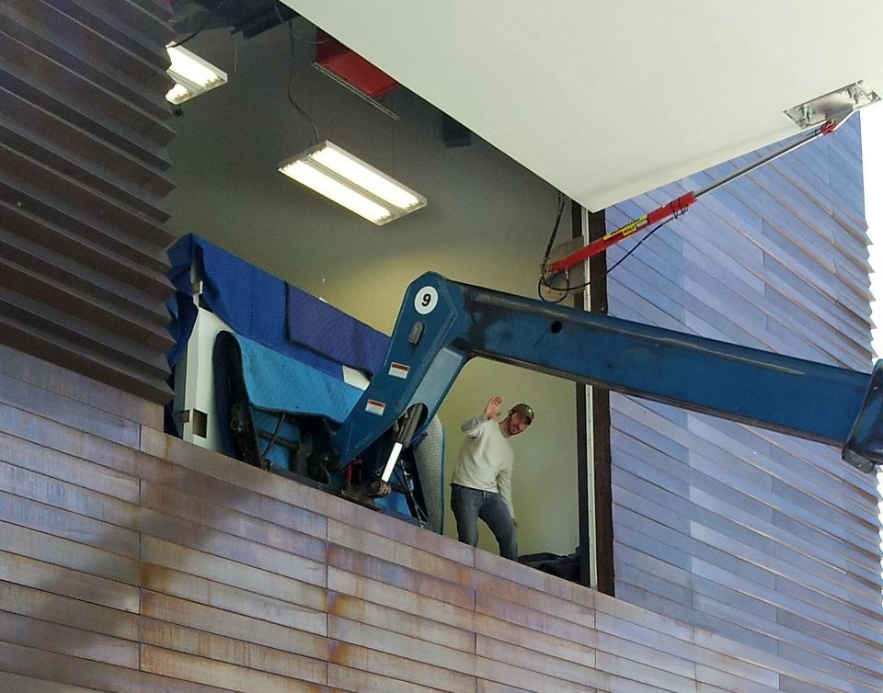
Fork lift raising exhibit cases to second floor of SHOF

Attendance:
E.D. White Historic Site
April Total Attendance: 355

General Admission: 257
Special Admission: 98

Special admission included: BTNEP Paddle Bayou Lafourche

Louisiana State Museum – Patterson
April Total Attendance: 35,987

General Admission: 760
Special Admission: 35,043
School Groups (4) 184

Special Admission: Cypress Sawmill Festival Attendees

School Groups: J. B. Maitland, Gibson Elementary, and two groups from Foster Elementary

Patterson’s attendance included visitors from 31 states including Louisiana.

Top five states visitors originated (excluding Louisiana):
- Arkansas
- North Carolina
- Oregon
- Mississippi
- South Carolina

Countries visitors originated: Canada, England, Italy, Switzerland, Scotland, and Zimbabwe

Capitol Park Museum
April Total Attendance: 9,782

General Admission: 2.028
Events: 4,499
School Groups 3,255

Physical Plant Report
Wade Levy
Currently, the maintenance crew is renovating the vacant apartment, 806 Chartres, 3rd floor. The apartment should be ready by the end of the summer.

Next week, the crew is going to install the reception desk at the SHOF and put some finishing touches on the installation cases.

Dawn Hammatt
Curatorial Services
Exhibition installation at the Louisiana Sports Hall of Fame and Regional History Museum are underway. Exhibition staff is in Natchitoches for the next month completing the project.

Battle of New Orleans Exhibition planning continues.

Ms. Hammatt was invited to attend an international forum Heritage Emergency Partnership, a convened by Historic Preservation in partnership with the Chief Officers of State Library Agencies. Heritage Preservation paid all travel expenses.

This summer we will be preparing the Arsenal and adjacencies for education programming next fall. The NOLA youth educator search is underway.

Friends of the Cabildo Report
Mr. Cangelosi said this is his last report as President.

He talked about the Cooperative Endeavor Agreement (CEA) between the FOC and LSM. The FOC provides support through walking tours, events, and fundraisers. They also have a docent program. In addition, the FOC provides $35,000 annually. This can used be for education, acquisitions/collections, or exhibits.

As of May 5th, the FOC, for this fiscal year, has:

A. Provided daily and special tours to 4,267 guests, raising just under $69,000.
B. Conducted fundraisers and events attended by 1,700 people, netting just over $23,000.
C. Upgraded the store, which has netted $26,600.

Upcoming FOC events include:
May 16 FOC Annual Meeting
May 18 Faubourg St. Mary Tour
May 18 Techung and the African Brass Band Concert
May 19 French Quarter Homes and Courtyards Tour Fundraiser
May 24 Irma Thomas Concert
June 22 Volunteer Recognition Luncheon

The new FOC President will be Robert Freeland.

Louisiana Museum Foundation Report
Susan Maclay read the report.

Dana Hansel will be giving her last speech as President of the LMF at the LMF’s annual meeting on May 15th. It will be at Ralph’s on the Park and Ms. Maclay said there is still time to join the LMF and attend the meeting. Jay Dardenne introduced Mark Tullos, who will be the keynote speaker.

Anne Redd will be the new LMF President.

The LMF is actively involved in the Music at the Mint program, which is doing very well.

Ms. Maclay and Mr. Tullos attended a Vieux Carre Foundation meeting at the end of April, 2013 and she introduced Mr. Tullos to a lot of area residents and business people.

Ms. Maclay said the LMF’s gala will be in October at the Mint. No particular date is set yet, but when she knows, she will inform the board.

Irby/Finance Committee Report
Dr. Powell gave the report.

Mr. Tullos requested to extend his stay at the Lower Pontalba museum apartment for the months of June, July and August under the same terms as previously approved. Unanimously approved.

Accessions Committee report
Dr. Perret said the report was e-mailed in advance for the board’s review (report attached). Unanimosly approved. At the last meeting, Dr. Perret said the policy regarding loans to government officials was discussed. That discussion is ongoing and will continue at the next meeting.

New Business
Mr. Robert J. Cangelosi, Jr., the outgoing President of the Friends of the Cabildo, was presented with a plaque thanking him for his work over the years. He thanked everyone and said he has enjoyed his time as President.

There will be no Board meetings in July or August. If emergency items arise, the Executive Committee will meet with subsequent approval by the full Board, if needed, at the September meeting.

Meeting adjourned.

